

***Series of smart gateways***

***SG***

*February 2020 • Version 1.00*

**Smart gateways**

**SG**

***User and Installation manual***

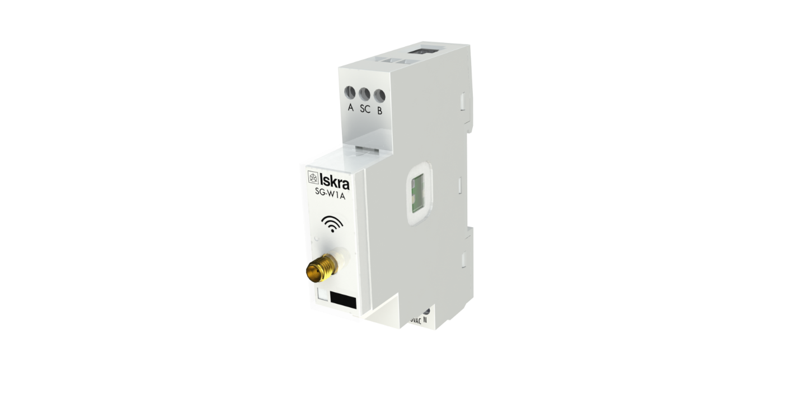

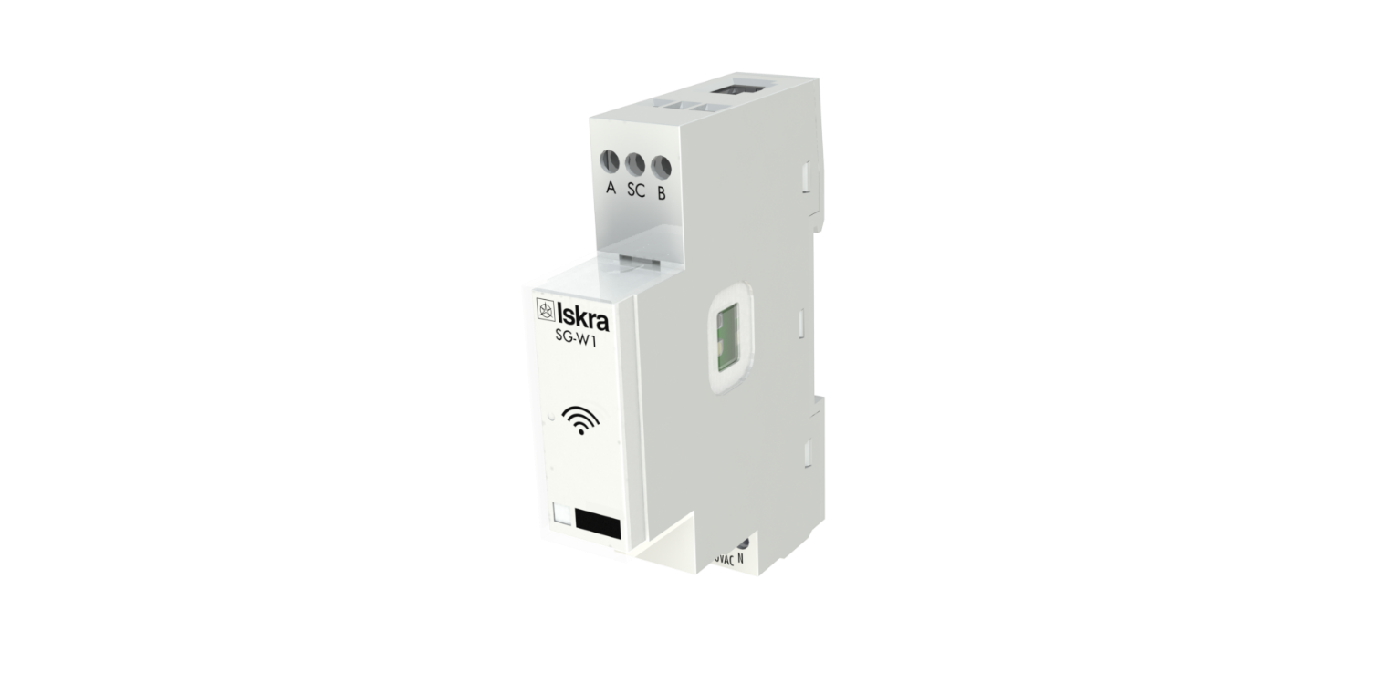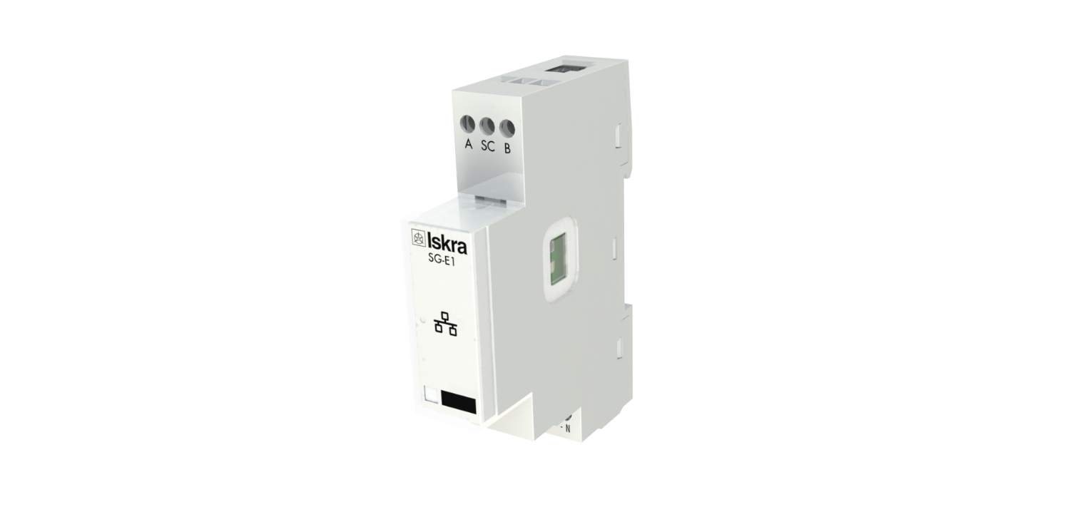

Security Advices and Warnings

Please read this chapter carefully and examine the equipment carefully for potential damages which might arise during transport and to become familiar with it before continue to install, energize and work with a SG.

This chapter deals with important information and warnings that should be considered for safe installation and handling with a device in order to assure its correct use and continuous operation.

Everyone using the product should become familiar with the contents of chapter »Security Advices and Warnings«.

If equipment is used in a manner not specified by the manufacturer, the protection provided by the equipment may be impaired.

**PLEASE NOTE**

*This booklet contains instructions for installation and use of SG. Installation and use of a device also includes handling with dangerous currents and voltages therefore should be installed, operated, serviced and maintained by qualified personnel only. ISKRA d.o.o. Company assumes no responsibility in connection with installation and use of the product. If there is any doubt regarding installation and use of the system in which the device is used for measuring or supervision, please contact a person who is responsible for installation of such system.*

Before switching the device ON

Check the following before switching on the device:

* Nominal voltage.
* Terminals integrity.
* Protection fuse for voltage inputs (recommended maximal external fuse size is 10 A).
* External switch or circuit breaker must be included in the installation for disconnection of the devices’ aux. power supply. It must be suitably located and properly marked for reliable disconnection of the device when needed.
* Proper connection and voltage level of I/O module.

Used symbols on devices’ housing and labels

|  |  |
| --- | --- |
| **SYMBOL** | **EXPLANATION** |
| C:\Users\mscetinec\AppData\Local\Microsoft\Windows\INetCache\Content.Word\Simbol_2.jpg | **DANGER**  Indicates proximity of hazardous high voltage, which might result in serious injury or death if not handled with care. |
|  | **WARNING**  Indicates situations where careful reading of this manual is required and following requested steps to avoid potential injury is advised. |
|  | Compliance of the product with directive 2002/96/EC, as first priority, the prevention of waste electrical and electronic equipment (WEEE), and in addition, the reuse, recycling and other forms of recovery of such wastes so as to reduce the disposal of waste. It also seeks to improve the environmental performance of all operators involved in the life cycle of electrical and electronic equipment. |
|  | Compliance of the product with European CE directives. |

Disposal

It is strongly recommended that electrical and electronic equipment (WEEE) is not deposit as municipal waste. The manufacturer or provider shall take waste electrical and electronic equipment free of charge. The complete procedure after lifetime should comply with the Directive 2002/96/EC about restriction on the use of certain hazardous substances in electrical and electronic equipment.

**Table of contents**

1. [1 Basic description and operation 1](#_Toc33079793)

[1.1 Description of the device 2](#_Toc33079794)

[1.2 Appearance 2](#_Toc33079795)

[1.3 SG application 3](#_Toc33079796)

[1.4 Main features 5](#_Toc33079797)

1. [2 CONNECTION 6](#_Toc33079798)

[2.1 Mounting 7](#_Toc33079799)

[2.2 Electrical connection 8](#_Toc33079800)

1. [3 FIRST STEPS 10](#_Toc33079801)

[3.1 Introduction 11](#_Toc33079802)

[3.2 Connecting SG to Wi-Fi Network 11](#_Toc33079803)

[3.3 SG IP address 13](#_Toc33079804)

[3.4 Configuring SG with MiQen configuration SW 17](#_Toc33079805)

[3.5 SG IoT 20](#_Toc33079806)

[3.6 Selecting device for publishing data 20](#_Toc33079807)

[3.7 SG WEB interface 24](#_Toc33079808)

1. [TECHNICAL DATA 30](#_Toc33079809)

[3.8 Mechanical characteristics of input 3-31](#_Toc33079810)

[3.9 Power Supply input 3-31](#_Toc33079811)

[3.10 LED 3-31](#_Toc33079812)

[3.11 Wi-Fi 3-31](#_Toc33079813)

[3.12 IR Serial communication 3-31](#_Toc33079814)

[3.13 Ethernet (only for SG-E1) 3-32](#_Toc33079815)

[3.14 RS485 Serial communication 3-32](#_Toc33079816)

[3.15 Digital input 3-32](#_Toc33079817)

[3.16 Temperature sensor (Pt1000) input 3-32](#_Toc33079818)

[3.17 Safety and ambient conditions 3-32](#_Toc33079819)

[3.18 EC DIRECTIVES CONFORMITY 3-33](#_Toc33079820)

[3.19 Dimensions 3-33](#_Toc33079821)

1. [4 Abbreviation/Glossary 34](#_Toc33079822)

# Basic description and operation

This chapter presents all relevant information about the SG required to understand its purpose, applicability and basic features related to its operation.

In this chapter, you will find:

1.1 Description of the device 2

1.2 Appearance 2

1.3 SG application 3

1.4 Main features 5

## Description of the device

The SG series of smart gateways are intended to connect various equipment into communication network. The gateway has build-in two optical (IR) communication ports and the RS485 serial communication with the MODBUS protocol. RS485 communication enables data transmission and consequently the connection of communication gateway into the RS485 network and communication with various equipment, consisting of RS485 communication (e.g. energy meters, bistable switches, power monitoring devices, etc.), via MODBUS.

The SG series also consist of pulse input and temperature sensor (Pt1000) input.

The SG-W1 version is equipped with Wi-Fi communication. This type also has an alternative version with an external antenna.

The SG-E1 version is equipped with Ethernet communication. Activation of Wi-Fi communication (via parameter) is also possible with this device, but in that case, the Ethernet will not be active on RJ45.

## Appearance

|  |  |
| --- | --- |
| 1. **RJ-45 terminal** *can be utilized either for RS485 communication or for Ethernet communication (only for SG-E1)* 2. **RS485 communication** 3. **IR communication port** *(one on each side)* 4. **DIN-rail fitting** 5. **External antenna** *(only for SG-W1A)* 6. **Multifunctional green, red, orange LED** 7. **Power supply** 8. **Power input and temperature sensor (Pt1000) input** |  |

***Figure 1:*** *Appearance of smart gateway iHUB-L2.*

A built-in LED diode indicates different operation states of the SG. A tactile switch is built-in for reset and factory reset of a gateway. Short press resets the gateway, pressing button for more than 5 seconds (LED diode starts blinking fast) will do a factory reset (meaning setting SG to factory settings and turn into access point mode). Connecting terminals are built to be fastened according to EN 60715 standard. The SG interface with corresponding equipment enables setting and reading the instruments.

## SG application

The SG can be used in a variety of applications including:

* Single-phase single point metering and control.
* Three-phase single point metering and control.
* Connecting different devices via IR communication and RS485 communication.
* Connecting different devices via Wi-Fi (e.g. Pt1000 temperature sensor).
* Monitoring single or multiple devices.

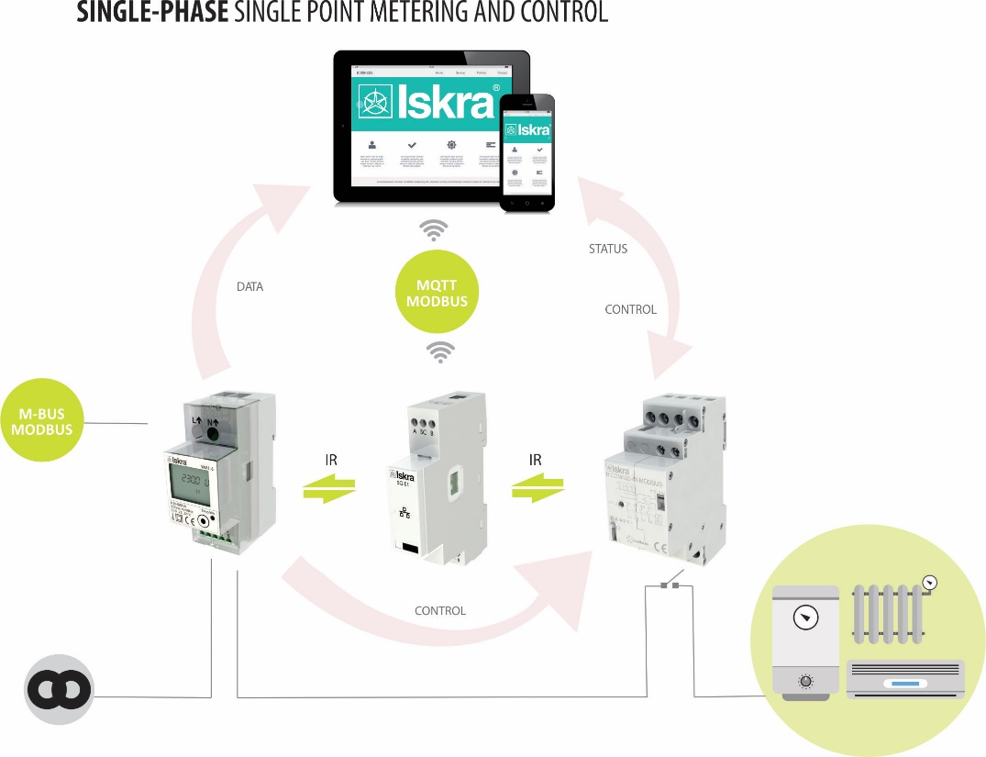

**Figure 2:** Connection diagram for SG. It is connected to an energy meter (on the left side of the SG) and to latching switch (on the right side of the SG) by IR communication. It is possible to read and control data with the computer or mobile phone.

*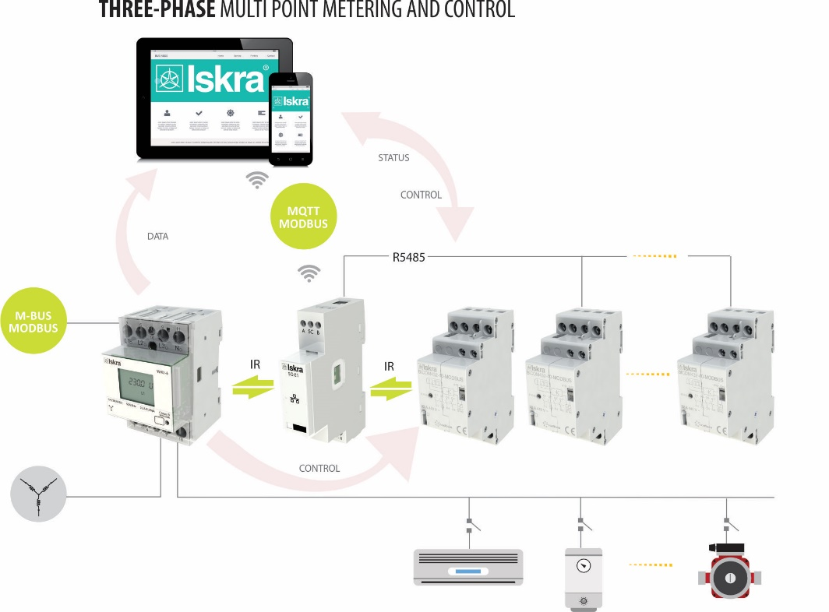*

**Figure 3:** Connection diagram for SG for connection to three-phase energy meter. It is connected to an energy meter (on the left side of the SG); to one latching switch (on the right side of the SG) by IR communication and to two latching switches by RS485 communication. It is possible to read and control data with the computer or mobile phone.

## Main features

* AC mains power supply.
* Nominal supply voltage (Un) from 85 V to 265 V AC or 85 V to 300 V DC.
* Nominal frequencies 50 Hz and 60 Hz.
* Multifunctional front green (operational mode), red (error) and orange (upgrading mode) LED.
* RS485 serial communication.
* IR serial communication (2 ports).
* Wi-Fi communication (can operate with or without an external antenna).
* Ethernet communication (valid only for SG-E1)
* 1-DIN rail width mounting communication gateway according to EN 60715.
* Pulse and temperature input.
* SG-W1 can only operate with an external antenna.

# CONNECTION

This chapter deals with the instructions for SG connection. Both the use and connection of the device includes handling with dangerous currents and voltages. Connection shall, therefore, be performed ONLY a by a qualified person using an appropriate equipment. ISKRA, d.o.o. does not take any responsibility regarding the use and connection. If any doubt occurs regarding connection and use in the system which device is intended for, please contact a person who is responsible for such installations.

In this chapter you will find:

Mounting 7

Electrical connection 8

## Mounting

The SG is intended only for DIN-rail mounting. It should be mounted on a DIN-rail between an energy meter and latching switch.

WARNING

Case is sealed. Do not open the device. No warranty if case is opened.

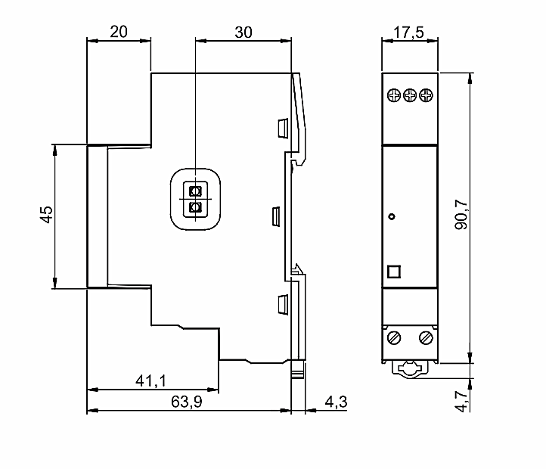

***Figure 4:*** *Dimensional drawings of SG-W1 and E1.*

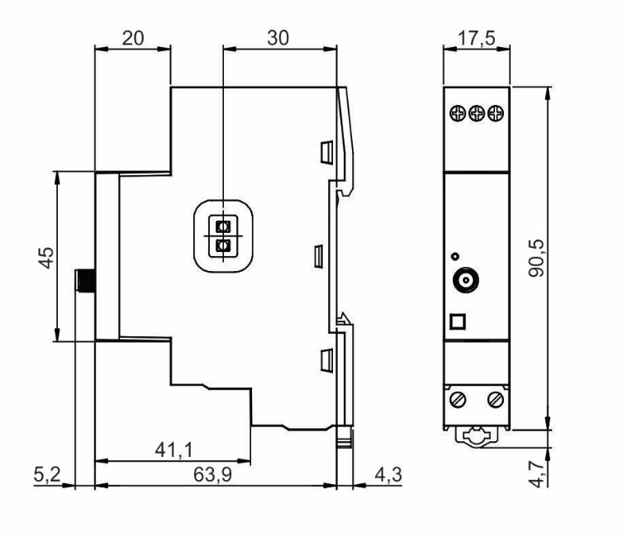

***Figure 4:*** *Dimensional drawings of SG-W1 with an external antenna.*

## Electrical connection

WARNING

Installation must be carried out and inspected by a specialist or under his supervision. Wrong or incomplete connection of voltage or other terminals can cause non-operation or damage to the device.

The SG should be connected to power supply voltage. Two IR communication ports are assembled into the gateway, one on each side. The left one communicates with energy meter, the right one is meant to connect to latching switch. The latching switch can be turned on/off by energy meter with set limit values or by user via Wi-Fi network using dedicated software (e.g. MiQen software).

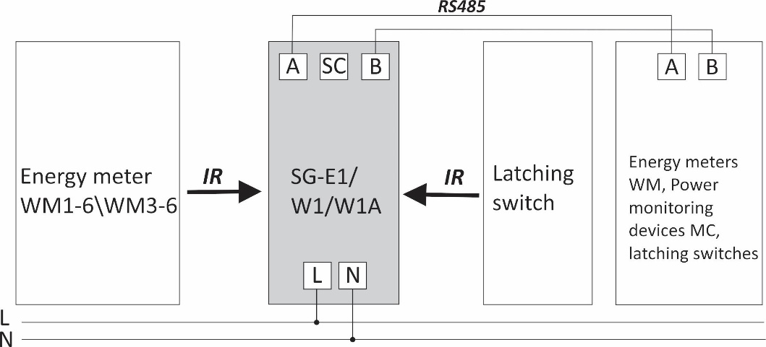

***Figure 5:*** *IR and RS485 connection of SG.*

Additionally, devices (e.g. energy meters, bistable switches, power monitoring devices, etc.) can be connected to the gateway via RS485 communication.

All devices connected to SG are visible at their addresses.

Up to 2 devices can be connected to the RS485 network allowing the SG to manage 4 devices altogether (1 energy meter and 1 latching switch via IR MODBUS communication, additionally managing 2 devices via RS485 communication).

**PLEASE NOTE**

For proper operation of the IR communication, avoid a powerful external source of light.

***Communication connection***

The complete SG system is assembled with three main units and two optionally units, which are used for communication with outside world:

* **The power supply unit.**

SG is supplied from AC power mains with nominal voltage 230 V. An isolated SMPS power supply is used to supply main MCU as well as Wi-Fi module, communication units and MCU peripherals.

* **The processing unit (MCU) with IR communication, RS485 communication, LED indicator and Switch for reset/factory reset.**

IR communication unit and RS485 unit are connected to MCU via UART interface. Various equipment can be connected to SG communication gateway via IR communication or via RS485 communication. Both IR communication modules using MODBUS protocol.

* **Wi-Fi module.**

Wi-Fi module is equipped on each gateway and enables connection of SG to user's Wi-Fi network using TCP MODBUS protocol. Furthermore, Wi-Fi module communicates with main processing unit via UART interface.

* **Extension modules of SG (pulse input and temperature sensor (Pt1000) input)**

SG does not have any adjustable elements (e.g. potentiometers), which assures a better long-term stability.

|  |  |  |  |
| --- | --- | --- | --- |
| Terminals |  |  |  |
| Pulse input | Pulse - |  | Pulse + |
| Power supply | N |  | L |
| RS485 communication | A | SC | B |
| Temperature sensor | Pt1000 |  | Pt1000 |
|  |  |  |  |

**Table 1:** Survey of communication connection

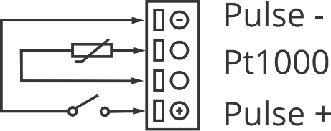

**Figure 6:** Pulse and temperature sensor connection of SG

**PLEASE NOTE**

Check labels on the side of the meter to check what modules are built in.

# FIRST STEPS

Programming a SG is very transparent and user friendly. Numerous settings are organized in groups according to their functionality.

In this chapter you will find basic programming steps:

3.1 Introduction 11

3.2 Connecting SG to Wi-Fi Network 11

3.2.1.1 SETUP SG IN CONFIGURATION MODE 12

3.3 SG IP address 13

3.3.1 Find IP address with MiQen 13

3.3.2 Find IP using Fing application on Android 15

3.3.3 Find IP using Apple Bonjour 16

3.3.4 Find IP using Windows file manager 16

3.4 Configuring SG with MiQen configuration SW 17

3.4.1 Connecting MiQen to SG via Wi-Fi 17

3.4.2 Connecting MiQen to SG via RS485 17

3.4.3 Connecting to SG 18

3.5 SG IoT 20

3.6 Selecting device for publishing data 20

3.6.1 Measurements data format 21

3.6.2 Energy counters data format 22

3.6.3 IoT use cases 23

3.7 SG WEB interface 24

3.7.1 Status page 24

3.7.2 SG Settings 24

3.7.3 RS485 Devices 26

3.7.4 Counters 26

3.7.5 Measurements 26

3.7.6 Power graph 27

3.7.7 Maximum demand 27

3.7.8 Device Settings 28

3.7.9 Bicom control 28

3.7.10 Upgrade 29

## Introduction

Connecting the SG is very transparent and user friendly. The flowchart below illustrates the first few steps to more clearly understanding software settings.

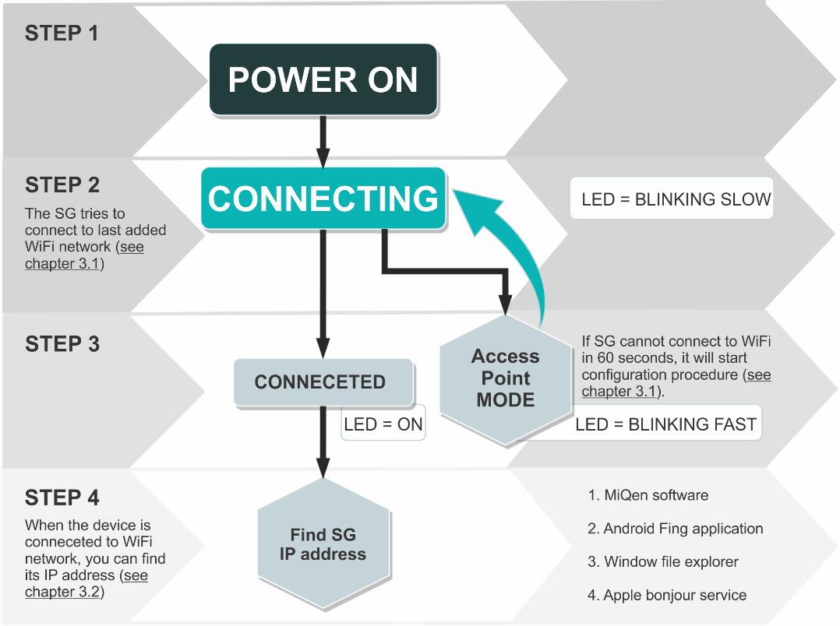

**Figure 7:** Process flowchart

## Connecting SG to Wi-Fi Network

After we mounted SG on a DIN-rail and supplied it with AC power (power-up the device), we must connect SG to Wi-Fi network. At first, SG tries to connect to last successfully added Wi-Fi network. If SG cannot connect to Wi-Fi in 30 seconds, it will start configuration procedure. This mode is active for 3 minutes and after that, it cycles to connection mode again.

#### SETUP SG IN CONFIGURATION MODE

|  |  |
| --- | --- |
| Start Iskra BLE Prov application on your Smartphone. |  |
| **Figure 8: BLE Prov application 1st screen** |

|  |  |  |
| --- | --- | --- |
| Click on Start provisioning to find SG.  If no device is found, check if orange LED is blinking fast and click Scan Again.  Otherwise click on device name “PROV\_1B9D3D” in this case. | |  |
| **Figure 9: Found devices screen** | |
| Next you need to enter Proof Of Possession PIN and click Next |  | |
| **Figure 10: Proof of possession screen** |

|  |  |
| --- | --- |
| SG will find available WiFi networks. Select one of them and enter password on next screen.  If you have hidden Wi-Fi network, select Join Other Network. |  |
| **Figure 11:** Sign in to network |
|  |  |

## SG IP address

If the previous step is completed, SG will connect to Wi-Fi network. In order to connect to SG, you must find its IP address. There are several ways to find it:

1. MiQen configuration SW (Browse Ethernet devices)
2. Android Fling application
3. Windows file explorer
4. Apple bonjour service

### Find IP address with MiQen

MiQen software is a tool for complete programming and monitoring of ISKRA measuring instruments. Remote operation is possible by means of serial (RS485/RS232), USB or TCP/IP communication. A user-friendly interface consists of six segments (Connection, Settings, Measurements, Analysis, My devices, and Upgrades). These segments are easily accessed by means of six icons on the left side.

The latest version of MiQen software can be downloaded from ISKRA d.o.o. website <https://www.iskra.eu/>.

PLEASE NOTE

MiQen has a very intuitive help system. All functions and settings are described in Info window on the bottom of MiQen window. In MiQen Help file, detailed instructions about software usage, connection, and communication with a different type of devices, driver installation, etc. are described.

MiQen has a functionality to search for network devices. Your PC must be connected to the same network as SG! All settings can be programmed using MiQen software.

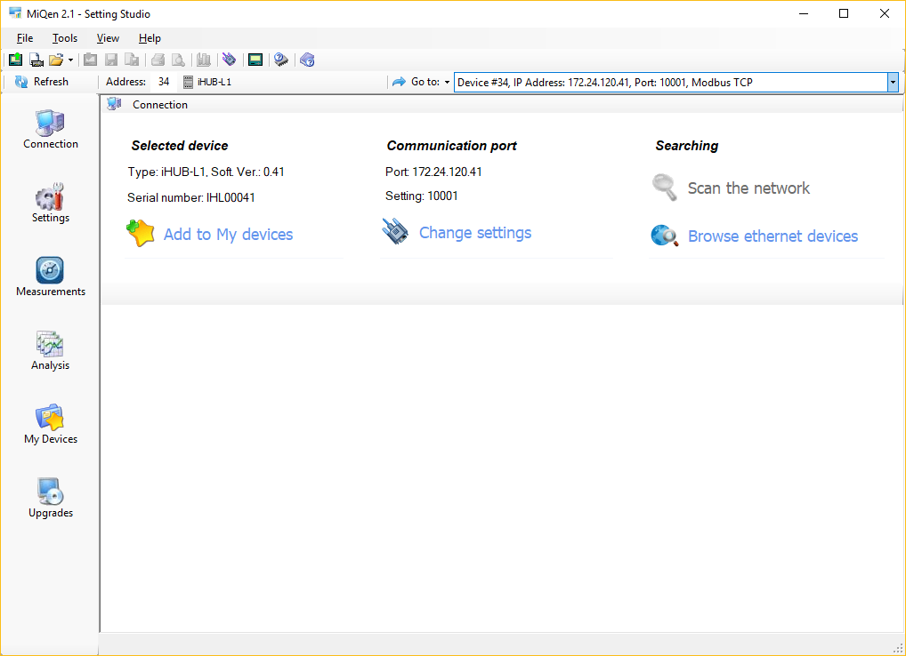

**Figure 11:** MiQen programming and monitoring software

Start MiQen application and click on Browse Ethernet devices.

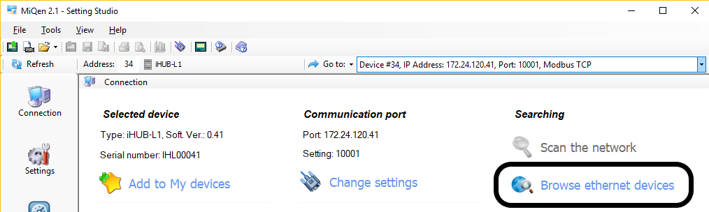

**Figure 12:** Browse ethernet devices selection

MiQen scans Wi-Fi network and displays results. You get a list of all detected devices on your network. You can double click on your device and MiQen will establish a connection with it.

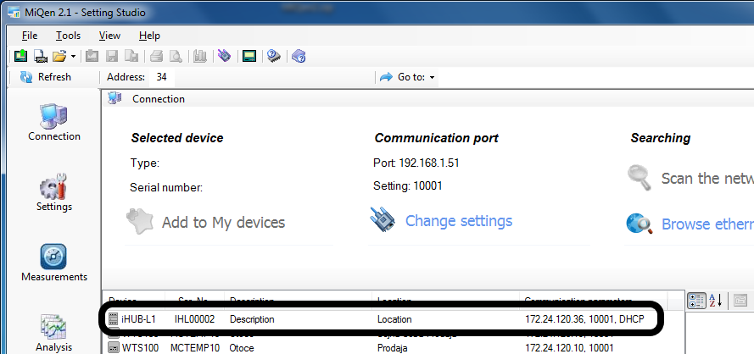

**Figure 13:** List of all detected devices. Double click on SG device

PLEASE NOTE

If you can not see your device, click on Browse Ethernet devices again.

### Find IP using Fing application on Android

If you are using Android smartphone, you can use Fing application from Google Play Store. Your smartphone must be connected to same Wi-Fi network as SG.

|  |  |
| --- | --- |
| Start Fing application and find the SG. |  |
| **Figure 14:** SG name in Fling application |

### Find IP using Apple Bonjour

If you have installed Apple Bonjour, than you can find IP address by using SG's serial number. In WEB browser's address bar type: <http://IHL00002.local> where IHL000002 is serial number.

### Find IP using Windows file manager

You can find SG's IP address also with file explorer in windows. PC must be connected to the same network as SG. Open explorer and click on *Network*. If you get prompt that network discovery is disabled, enable it.

Windows will give a list of all network devices. SG device name is starting with IHL. Double click on *IHLxxxxxx* and SG's WEB page will open. There you can see its IP address.

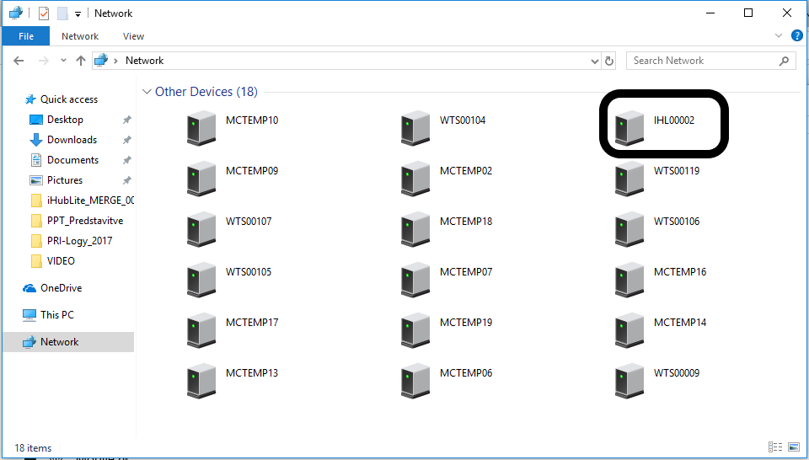

**Figure 15:** SG name in Windows file manager

## Configuring SG with MiQen configuration SW

Start the MiQen application and then click on Change settings under Communication port. There are two ways to connect MiQen to SG, via Wi-Fi or via the RS485 connection.

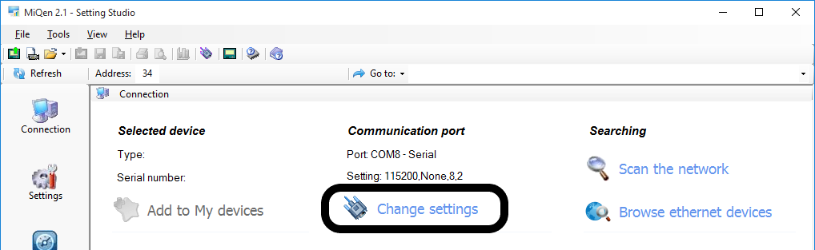

**Figure 16:** Change settings selection

### *Connecting MiQen to SG via Wi-Fi*

|  |  |
| --- | --- |
| For connecting in this mode, we need IP address of SG (see chapter 3.2). Enter SG IP address, IP port (default is 10001) and click OK. Set SG address to 34 and click *Refresh*. |  |
| **Figure 17:** Communication port for connecting MiQen to SG via Wi-Fi |

### Connecting MiQen to SG via RS485

This connection works only is SG’s RS485 port is configured as a slave (Default setting). If you enable RS485 devices in settings, RS485 on SG becomes master and you can not use RS485 port for settings.

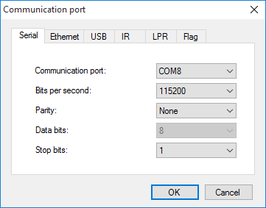If you want to connect via RS485, you need to wire your RS485 adapter to SG's RS485 port. Set communication port to COM on which you have RS485 adapter. Speed is 115200 bits/s, parity is none and Stop bits is 1.

Click *OK*.

Set SG address to 34 and click *Refresh*.

**Figure 18:** Communication port for connection MiQen to SG via RS485

### Connecting to SG

From now on, the procedure is the same, no matter if you connect via Wi-Fi or RS485. Set Address to 34 and click *Refresh*.

WARNING!

It is very important to set address to 34!

If settings are correct, you can see SG under Selected device. Click on *Settings* icon and click *Read settings*.

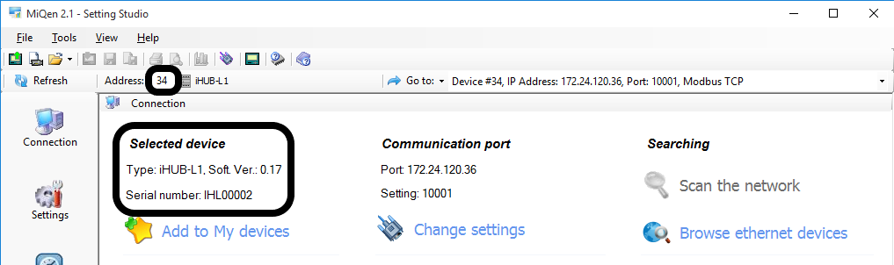

**Figure 19:** Set Address to 34

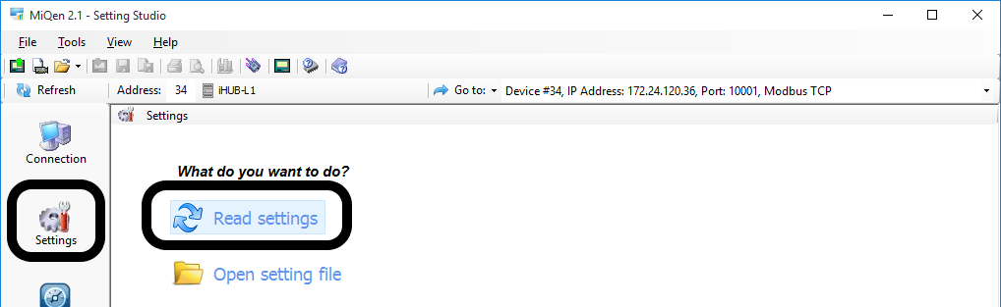

**Figure 20:** Read settings selection

MiQen will download settings and you can check and set settings.

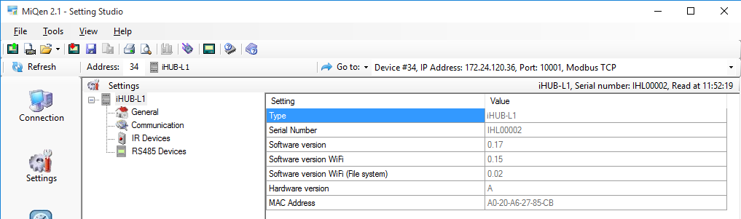

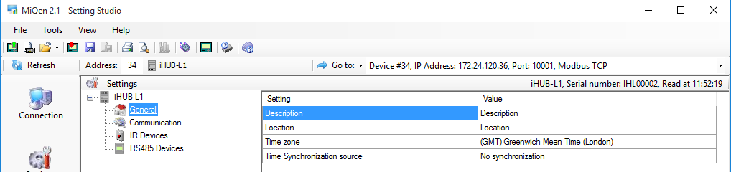

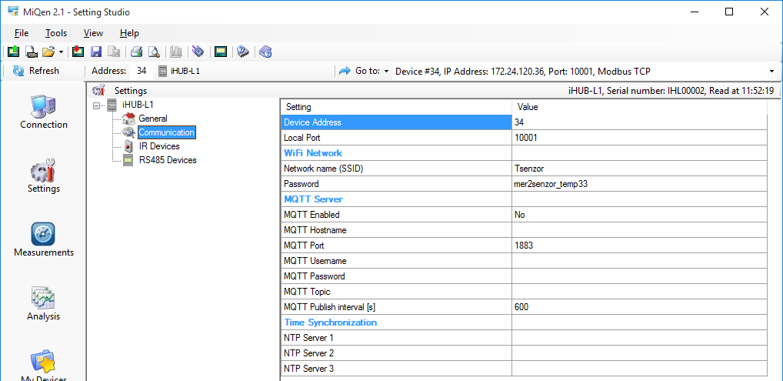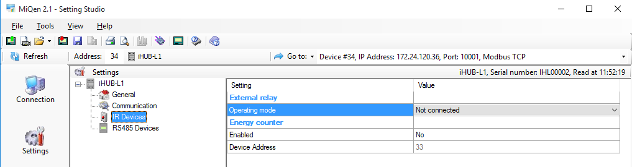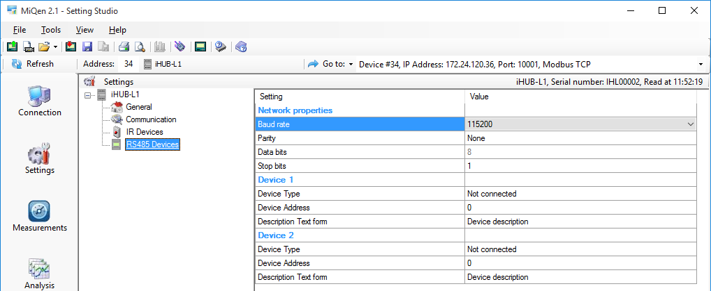

**Figure 21:** MiQen settings

WARNING

If MiQen is connected to SG via RS485, it will lose connection if you change Device Type from not connected to any other type.

## SG IoT

The SG can be used to publish one device's measurements to MQTT broker or serve data via TCP REST API. The data format in both cases is JSON.

## Selecting device for publishing data

If more than one device is connected to SG, there is a priority list for publishing IoT data.

1st priority: left IR device

2nd priority: RS485 Device 1

3rd priority: RS485 Device 2

### Measurements data format

{

"model":"MC666 Analyzer ",

"measurements":

{

"frequency":"50.032 Hz",

"U1":"221.92 V",

"U2":"228.95 V",

"U3":"228.56 V",

"I1":"0.548 A",

"I2":"0.718 A",

"I3":"0.144 A",

"P0":"213.5 W",

"P1":"63.9 W",

"P2":"127.92 W",

"P3":"21.67 W",

"Q0":"-25.42 var",

"Q1":"-103.7 var",

"Q2":"103.19 var",

"Q3":"-24.92 var",

"S0":"319.19 VA",

"S1":"121.78 VA",

"S2":"164.36 VA",

"S3":"33.0 VA",

"PF0":"0.6689 Cap",

"PF1":"0.5247 Cap",

"PF2":"0.7783 Ind",

"PF3":"0.6568 Cap",

"PA0":"-6.79",

"PA1":"-47.18",

"PA2":"37.93",

"PA3":"41.62",

"tariff":"1"

},

"timestamp":"1539260709",

"local\_time":"11.10.2018 12:25:09"}

### Energy counters data format

{

"model":"MC666 Analyzer ",

"measurements":

{

"counter1":"51550.4 kWh",

"counter2":"73835.1 kWh",

"counter3":"125385 kWh",

"counter4":"590.39 kWh"},

"settings":

{

"phase1":"Total",

"phase2":"Total",

"phase3":"Total",

"phase4":"Phase3",

"tariff1":"1",

"tariff2":"2",

"tariff3":"1,2",

"tariff4":"1,2"

},

"timestamp":"1539260946",

"local\_time":"11.10.2018 12:29:06"

}

### IoT use cases

You can use SG to connect energy meter with RS485 communication to home automation SW like “Home assistant”.

***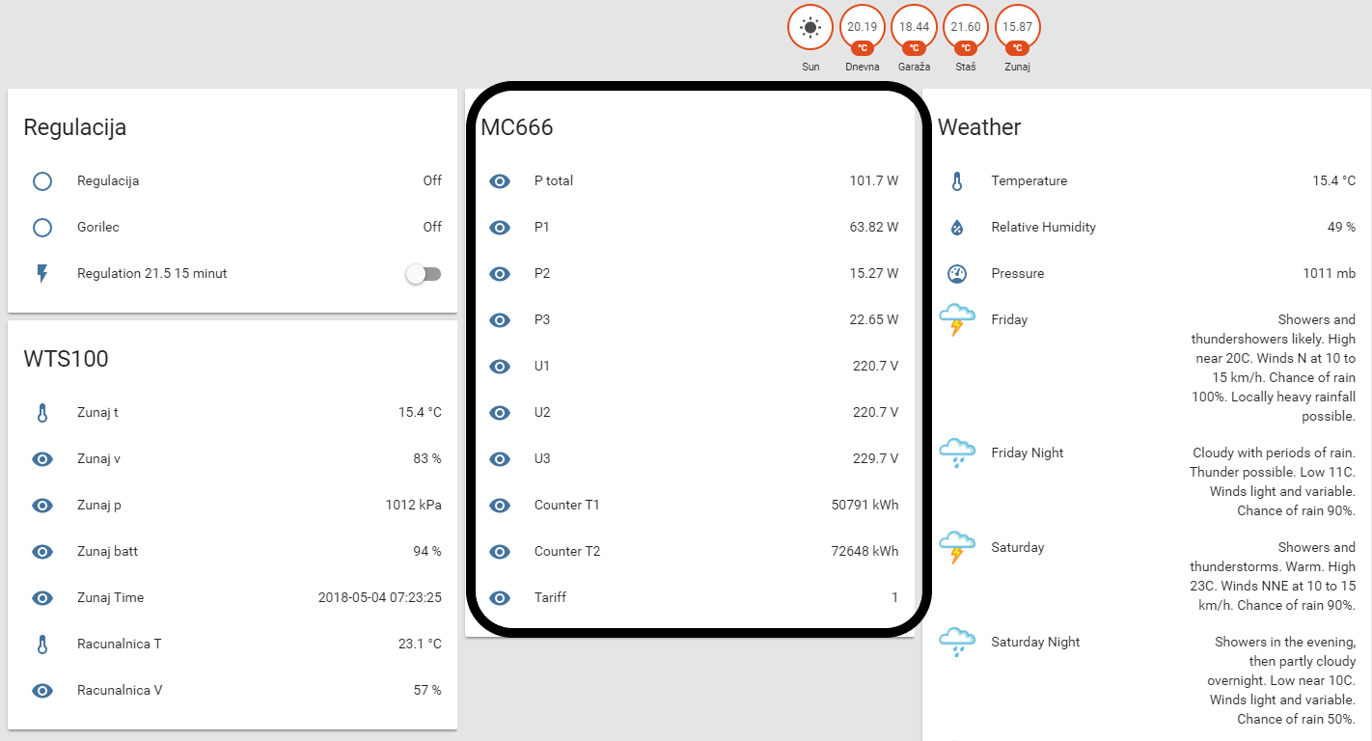***

**Figure 22:** Home assistant screen

MC666 is energy meter, Home assistant is configured to read active powers and voltages.

## 

## SG WEB interface

The SG WEB interface is intended to display statuses, settings, measuring data and provide an interface for SW upgrade.

Pages for measuring data displays results of the highest priority connected device (if you have more than one device connected).

### Status page

Status provides basic device status and settings.

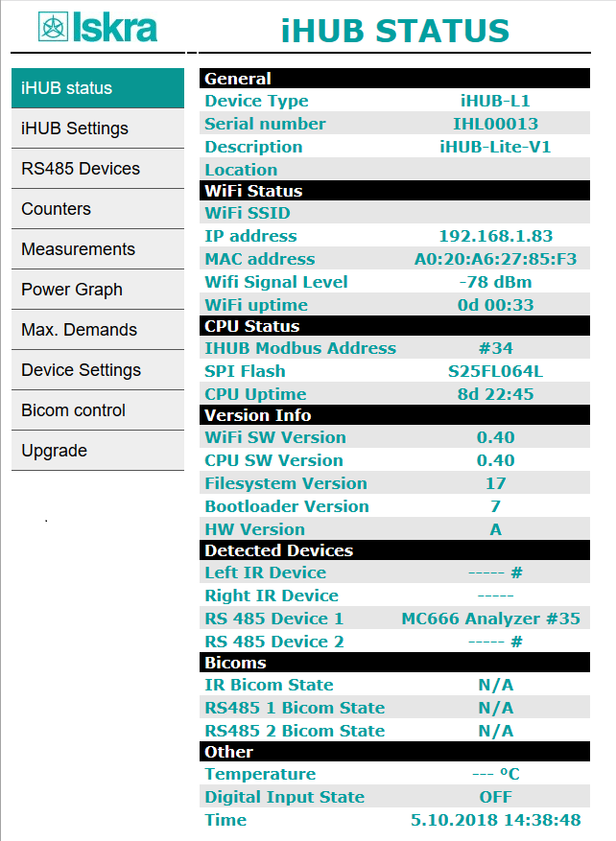

**Figure 23:** ISKRA SG status screen

### SG Settings

SG Settings segment consists of General, Communication, IR Devices, and RS485 Devices section. General section is intended for general settings and time settings. Communication section sets SG communication and MQTT settings. IR Devices section is intended for IR relay and IR counter settings. RS485 Devices sets settings of RS485 communication.

|  |  |
| --- | --- |
| a) | b) |
| c) | d) |

**Figure 24:** iHUB Settings screen, **a)** General section, **b)** Communication, **c)** IR Devices, **d)** RS485 Devices

### RS485 Devices

RS485 Devices segment displays connected devices to the RS485 bus. For the first time, you need to click on Scan RS485 Bus button. Finding connected devices will take around one minute.

**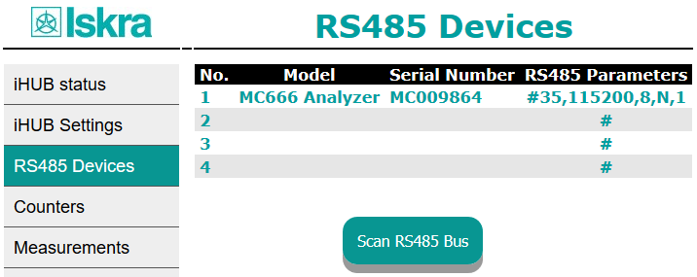**

**Figure 25:** RS485 Devices screen

### Counters

Counters page displays energy counter values.

***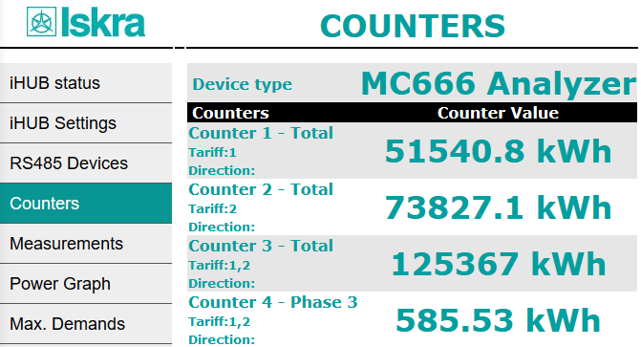***

**Figure26:** COUNTERSscreen

### Measurements

Measurements page displays basic measuring data from one connected device.

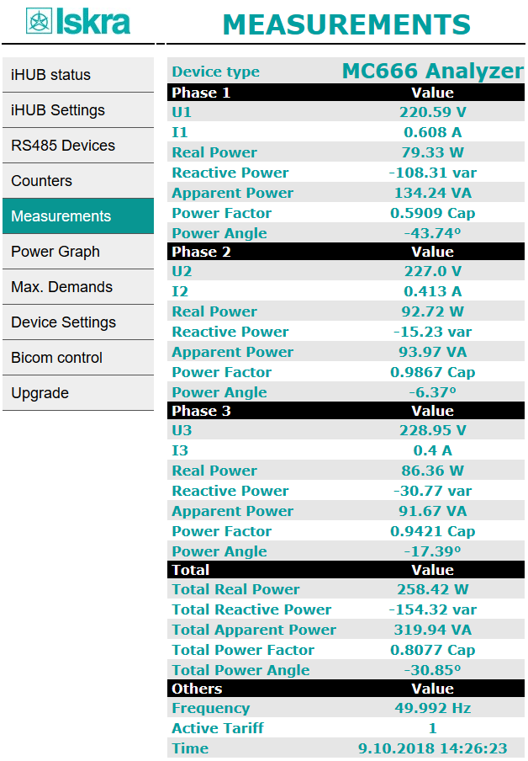

**Figure 27:** MEASUREMENTS screen

### Power graph

Power graph page displays measurements of energy per time (last 24 hours).

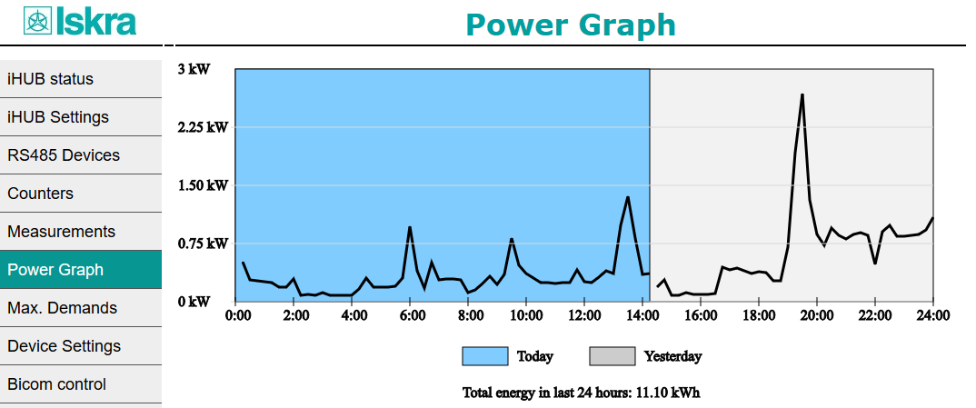

**Figure 28:** Power graph screen

### *Maximum demand*

Maximum demands are displayed only for a device, which supports this measurement (PQ meters). If energy meter is connected, results will be undefined.

***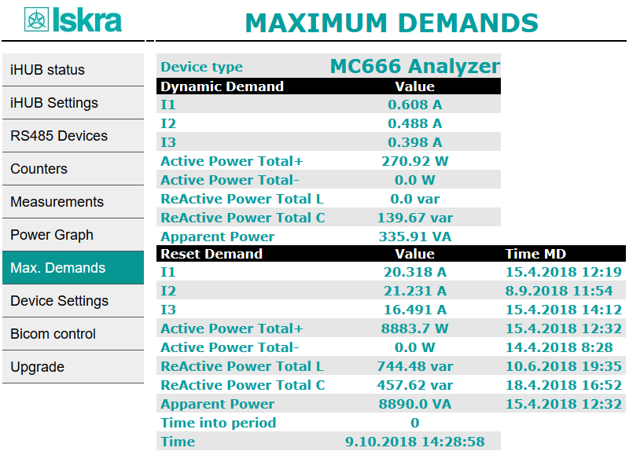***

**Figure 29:** MAXIMUM DEMANDS screen

### 

### Device Settings

Settings page also contains value from connected device.

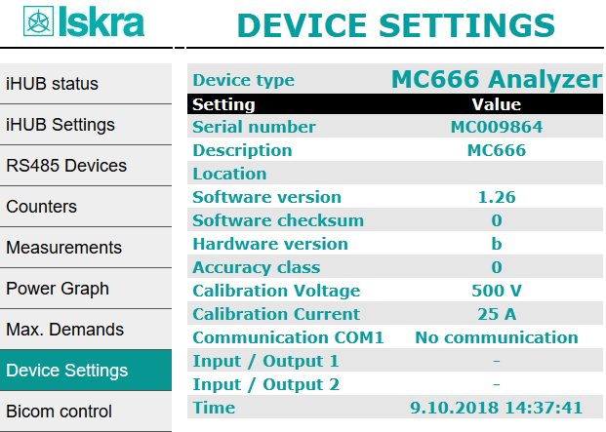

**Figure 30:** SETTINGS screen

### Bicom control

There are three bicom controls on web page. Every Bicom has ON, OFF and Toggle button.

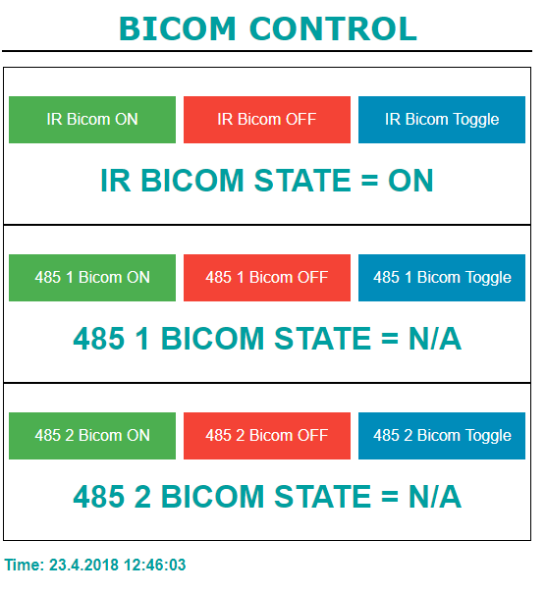

**Figure 31:** BICOM CONTROL screen

### 

### Upgrade

There are two upgrades available on WEB page.

***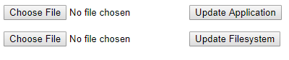***

**Figure 32:** Available upgrades

Top 2 buttons are intended for Wi-Fi application upgrade, while bottom buttons are used for file system upgrade. In both cases, you need to click on Choose File to select upgrade file and then click the right button to start to upgrade.

**TECHNICAL DATA**

In following chapter all technical data regarding operation of a three-phase electrical energy meter is presented.

Mechanical characteristics of input 3-31

Power Supply input 3-31

LED 3-31

Wi-Fi 3-31

RS485 Serial communication 3-32

Pulse input (optional) 3-32

Temperature sensor (Pt1000) input 3-32

Safety and ambient conditions 3-32

EC DIRECTIVES CONFORMITY 3-33

Dimensions 3-33

## Mechanical characteristics of input

Rail mounting according DIN EN 60715.

|  |  |  |
| --- | --- | --- |
| ***Terminals*** | | ***Max. conductor cross-sections*** |
| ***Main inputs*** | *Contacts capacity:* | *0.5 ${mm}^{2}$... 3 ${mm}^{2}$* |
| *Connection screws:* | *M3* |
| *Max torque:* | *0.5 Nm* |
| *Length of removed isolation:* | *6 mm* |
| ***RS485 module*** | *Contacts capacity:* | *0.5 ${mm}^{2}$... 3 ${mm}^{2}$* |
| *Connection screws:* | *M3* |
| *Max torque:* | *0.5 Nm* |
|  | *Length of removed isolation:* | *6 mm* |

## Power Supply input

|  |  |
| --- | --- |
| *Nominal voltage Un:* | *From 85 V to 265 V AC or 85 V to 300 V DC* |
| *Power consumption:* | *< 3 W* |
| *Nominal frequency fn:* | *50 Hz and 60 Hz* |
| *Length of removed isolation:* | *6 mm* |

## LED

|  |  |
| --- | --- |
| *Colour:* |  |
| *Green:* | *operational mode* |
| *Red:* | *error* |
| *Orange:* | *upgrading mode* |

## Wi-Fi

|  |  |
| --- | --- |
| *Protocol:* | *802.11 b/g/n* |
| *Data rate:* | *150 Mbps* |
| *Adjustable transmitting power:* | *20.5 dBm* |

## IR Serial communication

|  |  |
| --- | --- |
| *Type:* | *IR* |
| *Speed:* | *19200 bit/s* |
| *Frame:* | *8, N, 1* |
| *Protocol:* | *MODBUS RTU* |

## Ethernet (only for SG-E1)

* Compliant with IEEE 802.3/802.3u (Fast Ethernet)
* Compliant with ISO 802-3/IEEE 802.3 (10 BASE-T)

## RS485 Serial communication

|  |  |
| --- | --- |
| *Type:* | *RS485* |
| *Speed:* | *1200 bit/s to 115200 bit/s (default 115200 bit/s)* |
| *Frame:* | *8, N, 1* |
| *Protocol:* | *MODBUS RTU* |

## Digital input

|  |  |
| --- | --- |
| *Rated voltage:* | *230 V (-20%...+15%)* |
| *Input resistance:* | *450 kΩ* |

## Temperature sensor (Pt1000) input

|  |  |
| --- | --- |
| *Measuring method:* | two wire connection |
| *Input range with programmable ratings:* | |
| *RTD sensors limit values:* | *200 Ω - 10 kΩ* |
| *Measuring voltage:* | *≤ 3.3 V* |
| *Minimum temperature range:* | *100 K* |
| *Minimum differential resistance:* | *400 Ω (1000 Ω -> 1400 Ω)* |
| *Lead resistance:* | *< 10 Ω per lead* |
| *Consumption:* | *< 0.5 VA* |

## Safety and ambient conditions

According to standards for IEC 60950.

Temperature and climatic condition according to EN 62052-11.

|  |  |
| --- | --- |
| *Dust/water protection:* | *IP50* |
| *Operating temperature:* | *-25 °C - +55 °C* |
| *Storage temperature:* | *-40 °C - + 70 °C* |
| *Enclosure:* | *self extinguish, complying UL94-V* |

## 

## EC DIRECTIVES CONFORMITY

EU Directive on Measuring Instruments **2014/32/EU**

EU Directive on EMC **2014/30/EU**

EU Directive on Low Voltage **2014/35/EU**

EU Directive WEEE **2002/96/EC**

EU RED Directive **2014/53/EU**

## Dimensions

### Dimensional drawing

|  |  |  |
| --- | --- | --- |
| ***Construction*** | ***Appearance (SG-E1/W1)*** | ***Appearance (SG-W1A)*** |
| ***Dimensions*** | All dimensions are in mm |  |

## 

# Abbreviation/Glossary

Abbreviations are explained within the text where they appear the first time. Most common abbreviations and expressions are explained in the following table:

|  |  |
| --- | --- |
| ***Term*** | ***Explanation*** |
| *Ethernet* | *IEEE 802.3 data layer protocol* |
| *MODBUS / DNP3* | *Industrial protocol for data transmission* |
| *MiQen* | *Setting Software for ISKRA instruments* |
| *PI* | *Pulse input module* |
| *AC* | *Alternating quantity* |
| *IR* | *Infrared (optical) communication* |
| *Pt1000* | *Temperature sensor* |
| *PQ* | *Power Quality* |

List of common abbreviations and expressions